EXPERIMENT 6
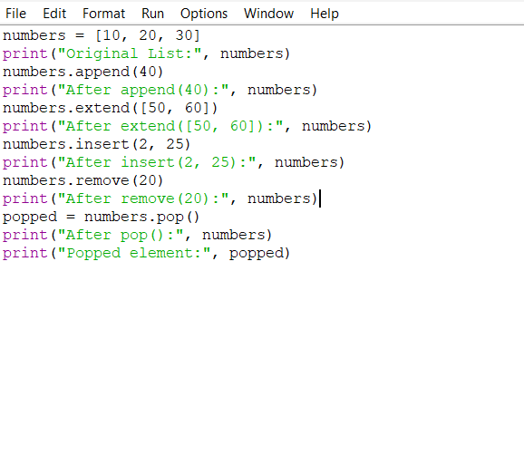
OUTPUT
